Conics

For circles / ellipses / parametrics and cartesians, I have used lots of variations on the matching activity.
One other thing that I have done once they have done differentiation is give each pair the equation of a circle. They then have to find a point on the circle and find the equation of the tangent to the circle at that point using two different methods (implicit differentiation from the Cartesian or parametric from the parametric equation which they have to find) and make sure that they are both the same. This is done on sugar paper working as a pair.

Below is a matching activity for conic sections.

CIRCLE  Centre (0,0)  Radius 4 | x² + y² = 16 | x = 4 cos t  y = 4 sin t | 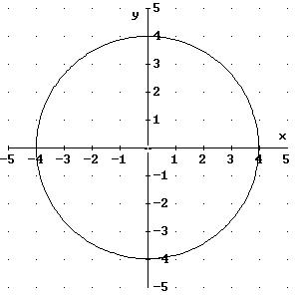
CIRCLE  Centre (3,2)  Radius 4 | x² + y² - 6x - 4y = 3 | x = 4 cos t + 3  y = 4 sin t + 2 | 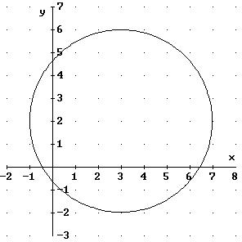
CIRCLE  Centre (-2,-3)  Radius 4 | (x + 2)² + (y + 3)² = 16 | x = 4 cos t – 2  y = 4 sin t – 3 | 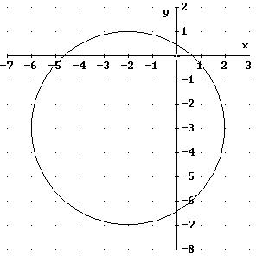
CIRCLE  Centre (2,-3)  Radius 4 | x² + y² - 4x + 6y = 3 | x = 4 cos t + 2  y = 4 sin t – 3 | 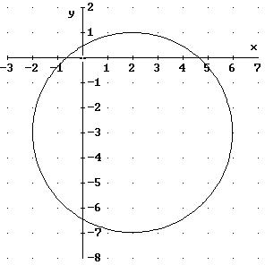

ELLIPSE  Centre (3,-1)  Major axis 6  Minor axis 4 | 4x² + 9y² - 24x + 18y + 9 = 0 | x = 3 cos t + 3  y = 2 sin t - 1 | 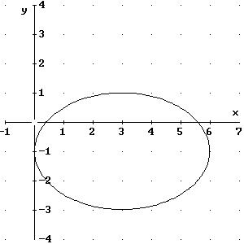
ELLIPSE  Centre (-3, 1)  Major axis 6  Minor axis 4 | 4(x + 3)² + 9(y - 1)² = 36 | x = 3 cos t – 3  y = 2 sin t + 1 | 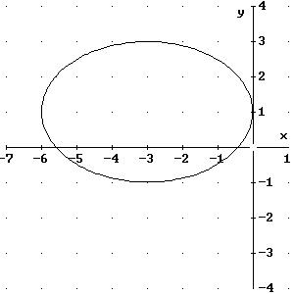
ELLIPSE  Centre (3,1)  Major axis 6  Minor axis 4 | 4x² + 9y² - 24x - 18y + 9 = 0 | x = 3 cos t + 3  y = 2 sin t + 1 | 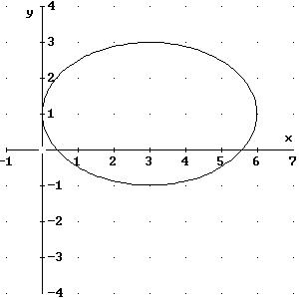
ELLIPSE  Centre (-3,-1)  Major axis 6  Minor axis 4 | (x + 3)² + (y + 1)² = 1  9 4 | x = 3 cos t – 3  y = 2 sin t – 1 | 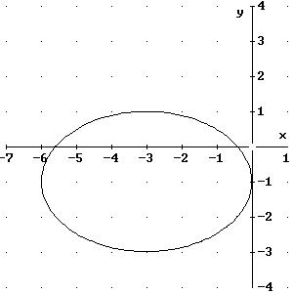

PARABOLA  Vertex at (0,2)  Focus at (0,6) | x² – 16y + 32 = 0 | x = 8t  y = 4t² + 2 | 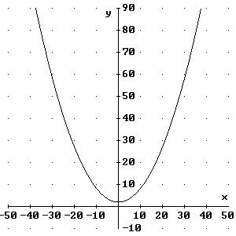
PARABOLA  Vertex at (2,0)  Focus at (7,0) | y² – 20x + 40 = 0 | x = 5t² + 2  y = 10t | 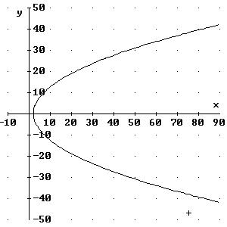
PARABOLA  Vertex at (0,2)  Focus at (0,7) | x² – 20y + 40 = 0 | x = 10t  y = 5t² + 2 | 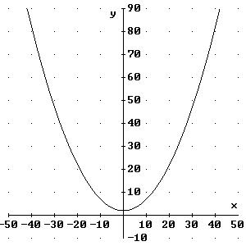
PARABOLA  Vertex at (2,0)  Focus at (6,0) | y² – 16x + 32 = 0 | x = 4t² + 2  y = 8t | 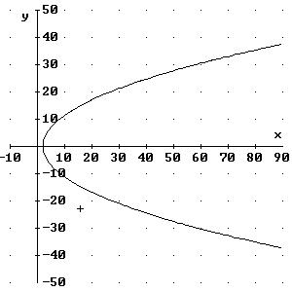

RECTANGULAR  HYPERBOLA  Asymptotes x = -5 & y = 0 | xy + 5y – 9 = 0 | x = 3t -5  y = 3  t | 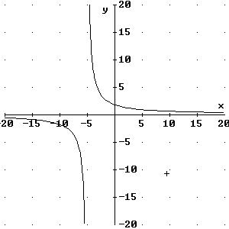
RECTANGULAR  HYPERBOLA  Asymptotes x = 0 & y = 3 | xy – 3x – 25 = 0 | x = 5  t  y = 5t + 3 | 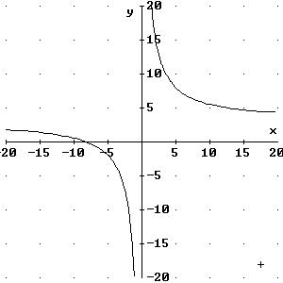
RECTANGULAR  HYPERBOLA  Asymptotes x = -3 & y = 0 | xy + 3y – 25 = 0 | x + 3 = 5t  y = 5  t | 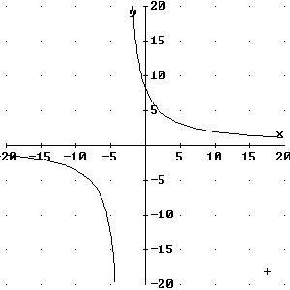
RECTANGULAR  HYPERBOLA  Asymptotes x = 0 & y = -5 | xy + 5x – 9 = 0 | x = 3  t  y = 3t - 5 | 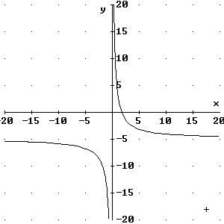

CIRCLE  Centre (0,0)  Radius 4 | CIRCLE  Centre (0,0)  Radius 4 | CIRCLE  Centre (0,0)  Radius 4 | CIRCLE  Centre (0,0)  Radius 4
CIRCLE  Centre (3,2)  Radius 4 | CIRCLE  Centre (3,2)  Radius 4 | CIRCLE  Centre (3,2)  Radius 4 | CIRCLE  Centre (3,2)  Radius 4
CIRCLE  Centre (-2,-3)  Radius 4 | CIRCLE  Centre (-2,-3)  Radius 4 | CIRCLE  Centre (-2,-3)  Radius 4 | CIRCLE  Centre (-2,-3)  Radius 4
CIRCLE  Centre (2,-3)  Radius 4 | CIRCLE  Centre (2,-3)  Radius 4 | CIRCLE  Centre (2,-3)  Radius 4 | CIRCLE  Centre (2,-3)  Radius 4

ELLIPSE  Centre (3,-1)  Major axis 6  Minor axis 4 | ELLIPSE  Centre (3,-1)  Major axis 6  Minor axis 4 | ELLIPSE  Centre (3,-1)  Major axis 6  Minor axis 4 | ELLIPSE  Centre (3,-1)  Major axis 6  Minor axis 4
ELLIPSE  Centre (-3, 1)  Major axis 6  Minor axis 4 | ELLIPSE  Centre (-3, 1)  Major axis 6  Minor axis 4 | ELLIPSE  Centre (-3, 1)  Major axis 6  Minor axis 4 | ELLIPSE  Centre (-3, 1)  Major axis 6  Minor axis 4
ELLIPSE  Centre (3,1)  Major axis 6  Minor axis 4 | ELLIPSE  Centre (3,1)  Major axis 6  Minor axis 4 | ELLIPSE  Centre (3,1)  Major axis 6  Minor axis 4 | ELLIPSE  Centre (3,1)  Major axis 6  Minor axis 4
ELLIPSE  Centre (-3,-1)  Major axis 6  Minor axis 4 | ELLIPSE  Centre (-3,-1)  Major axis 6  Minor axis 4 | ELLIPSE  Centre (-3,-1)  Major axis 6  Minor axis 4 | ELLIPSE  Centre (-3,-1)  Major axis 6  Minor axis 4

PARABOLA  Vertex at (0,2)  Focus at (0,6) | PARABOLA  Vertex at (0,2)  Focus at (0,6) | PARABOLA  Vertex at (0,2)  Focus at (0,6) | PARABOLA  Vertex at (0,2)  Focus at (0,6)
PARABOLA  Vertex at (2,0)  Focus at (7,0) | PARABOLA  Vertex at (2,0)  Focus at (7,0) | PARABOLA  Vertex at (2,0)  Focus at (7,0) | PARABOLA  Vertex at (2,0)  Focus at (7,0)
PARABOLA  Vertex at (0,2)  Focus at (0,7) | PARABOLA  Vertex at (0,2)  Focus at (0,7) | PARABOLA  Vertex at (0,2)  Focus at (0,7) | PARABOLA  Vertex at (0,2)  Focus at (0,7)
PARABOLA  Vertex at (2,0)  Focus at (6,0) | PARABOLA  Vertex at (2,0)  Focus at (6,0) | PARABOLA  Vertex at (2,0)  Focus at (6,0) | PARABOLA  Vertex at (2,0)  Focus at (6,0)

RECTANGULAR  HYPERBOLA  Asymptotes x = -5 & y = 0 | RECTANGULAR  HYPERBOLA  Asymptotes x = -5 & y = 0 | RECTANGULAR  HYPERBOLA  Asymptotes x = -5 & y = 0 | RECTANGULAR  HYPERBOLA  Asymptotes x = -5 & y = 0
RECTANGULAR  HYPERBOLA  Asymptotes x = 0 & y = 3 | RECTANGULAR  HYPERBOLA  Asymptotes x = 0 & y = 3 | RECTANGULAR  HYPERBOLA  Asymptotes x = 0 & y = 3 | RECTANGULAR  HYPERBOLA  Asymptotes x = 0 & y = 3
RECTANGULAR  HYPERBOLA  Asymptotes x = -3 & y = 0 | RECTANGULAR  HYPERBOLA  Asymptotes x = -3 & y = 0 | RECTANGULAR  HYPERBOLA  Asymptotes x = -3 & y = 0 | RECTANGULAR  HYPERBOLA  Asymptotes x = -3 & y = 0
RECTANGULAR  HYPERBOLA  Asymptotes x = 0 & y = -5 | RECTANGULAR  HYPERBOLA  Asymptotes x = 0 & y = -5 | RECTANGULAR  HYPERBOLA  Asymptotes x = 0 & y = -5 | RECTANGULAR  HYPERBOLA  Asymptotes x = 0 & y = -5

x² + y² - 6x - 4y = 3 | x² + y² - 6x - 4y = 3 | x² + y² - 6x - 4y = 3 | x² + y² - 6x - 4y = 3
(x + 2)² + (y + 3)² = 16 | (x + 2)² + (y + 3)² = 16 | (x + 2)² + (y + 3)² = 16 | (x + 2)² + (y + 3)² = 16
x² + y² - 4x + 6y = 3 | x² + y² - 4x + 6y = 3 | x² + y² - 4x + 6y = 3 | x² + y² - 4x + 6y = 3
x² + y² = 16 | x² + y² = 16 | x² + y² = 16 | x² + y² = 16

x = 4 cos t + 2  y = 4 sin t – 3 | x = 4 cos t + 2  y = 4 sin t – 3 | x = 4 cos t + 2  y = 4 sin t – 3 | x = 4 cos t + 2  y = 4 sin t – 3
x = 4 cos t  y = 4 sin t | x = 4 cos t  y = 4 sin t | x = 4 cos t  y = 4 sin t | x = 4 cos t  y = 4 sin t
x = 4 cos t + 3  y = 4 sin t + 2 | x = 4 cos t + 3  y = 4 sin t + 2 | x = 4 cos t + 3  y = 4 sin t + 2 | x = 4 cos t + 3  y = 4 sin t + 2
x = 4 cos t – 2  y = 4 sin t – 3 | x = 4 cos t – 2  y = 4 sin t – 3 | x = 4 cos t – 2  y = 4 sin t – 3 | x = 4 cos t – 2  y = 4 sin t – 3

4(x + 3)² + 9(y - 1)² = 36 | 4(x + 3)² + 9(y - 1)² = 36 | 4(x + 3)² + 9(y - 1)² = 36 | 4(x + 3)² + 9(y - 1)² = 36
4x² + 9y² - 24x - 18y + 9 = 0 | 4x² + 9y² - 24x - 18y + 9 = 0 | 4x² + 9y² - 24x - 18y + 9 = 0 | 4x² + 9y² - 24x - 18y + 9 = 0
(x + 3)² + (y + 1)² = 1  9 4 | (x + 3)² + (y + 1)² = 1  9 4 | (x + 3)² + (y + 1)² = 1  9 4 | (x + 3)² + (y + 1)² = 1  9 4
4x² + 9y² - 24x + 18y + 9 = 0 | 4x² + 9y² - 24x + 18y + 9 = 0 | 4x² + 9y² - 24x + 18y + 9 = 0 | 4x² + 9y² - 24x + 18y + 9 = 0

x = 3 cos t – 3  y = 2 sin t – 1 | x = 3 cos t – 3  y = 2 sin t – 1 | x = 3 cos t – 3  y = 2 sin t – 1 | x = 3 cos t – 3  y = 2 sin t – 1
x = 3 cos t + 3  y = 2 sin t + 1 | x = 3 cos t + 3  y = 2 sin t + 1 | x = 3 cos t + 3  y = 2 sin t + 1 | x = 3 cos t + 3  y = 2 sin t + 1
x = 3 cos t – 3  y = 2 sin t + 1 | x = 3 cos t – 3  y = 2 sin t + 1 | x = 3 cos t – 3  y = 2 sin t + 1 | x = 3 cos t – 3  y = 2 sin t + 1
x = 3 cos t + 3  y = 2 sin t - 1 | x = 3 cos t + 3  y = 2 sin t - 1 | x = 3 cos t + 3  y = 2 sin t - 1 | x = 3 cos t + 3  y = 2 sin t - 1

y² – 20x + 40 = 0 | y² – 20x + 40 = 0 | y² – 20x + 40 = 0 | y² – 20x + 40 = 0
x² – 16y + 32 = 0 | x² – 16y + 32 = 0 | x² – 16y + 32 = 0 | x² – 16y + 32 = 0
y² – 16x + 32 = 0 | y² – 16x + 32 = 0 | y² – 16x + 32 = 0 | y² – 16x + 32 = 0
x² – 20y + 40 = 0 | x² – 20y + 40 = 0 | x² – 20y + 40 = 0 | x² – 20y + 40 = 0

x = 10t  y = 5t² + 2 | x = 10t  y = 5t² + 2 | x = 10t  y = 5t² + 2 | x = 10t  y = 5t² + 2
x = 4t² + 2  y = 8t | x = 4t² + 2  y = 8t | x = 4t² + 2  y = 8t | x = 4t² + 2  y = 8t
x = 8t  y = 4t² + 2 | x = 8t  y = 4t² + 2 | x = 8t  y = 4t² + 2 | x = 8t  y = 4t² + 2
x = 5t² + 2  y = 10t | x = 5t² + 2  y = 10t | x = 5t² + 2  y = 10t | x = 5t² + 2  y = 10t

xy – 3x – 25 = 0 | xy – 3x – 25 = 0 | xy – 3x – 25 = 0 | xy – 3x – 25 = 0
xy + 3y – 25 = 0 | xy + 3y – 25 = 0 | xy + 3y – 25 = 0 | xy + 3y – 25 = 0
xy + 5x – 9 = 0 | xy + 5x – 9 = 0 | xy + 5x – 9 = 0 | xy + 5x – 9 = 0
xy + 5y – 9 = 0 | xy + 5y – 9 = 0 | xy + 5y – 9 = 0 | xy + 5y – 9 = 0
x + 3 = 5t  y = 5  t | x + 3 = 5t  y = 5  t | x + 3 = 5t  y = 5  t | x + 3 = 5t  y = 5  t
x = 3  t  y = 3t - 5 | x = 3  t  y = 3t - 5 | x = 3  t  y = 3t - 5 | x = 3  t  y = 3t - 5
x = 3t -5  y = 3  t | x = 3t -5  y = 3  t | x = 3t -5  y = 3  t | x = 3t -5  y = 3  t
x = 5  t  y = 5t + 3 | x = 5  t  y = 5t + 3 | x = 5  t  y = 5t + 3 | x = 5  t  y = 5t + 3

