Geometrical interpretation of the solutions of 3 simultaneous equations.

Set of equations | Algebraic Solution | Geometric Interpretation
3x+y-2z=7  2x+4y+z=8  5x-y+3z=9 |  | 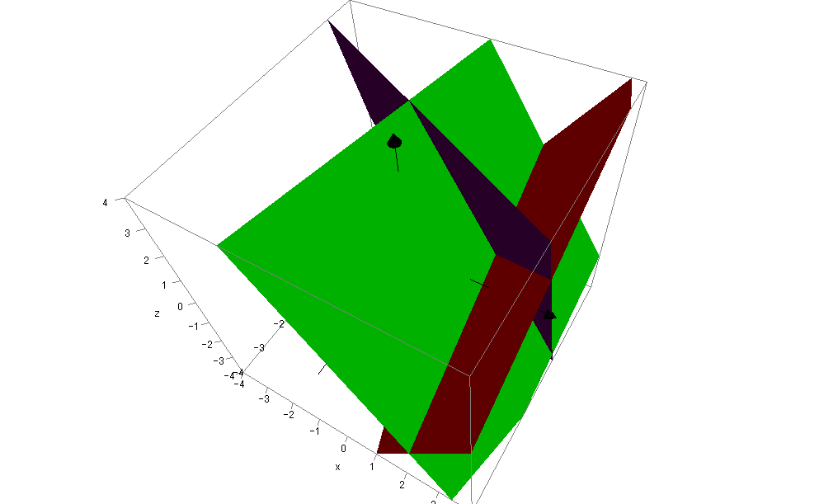
6x-7y+2z=4  6x-y-z=7  2x-3y+z=-10 |  | 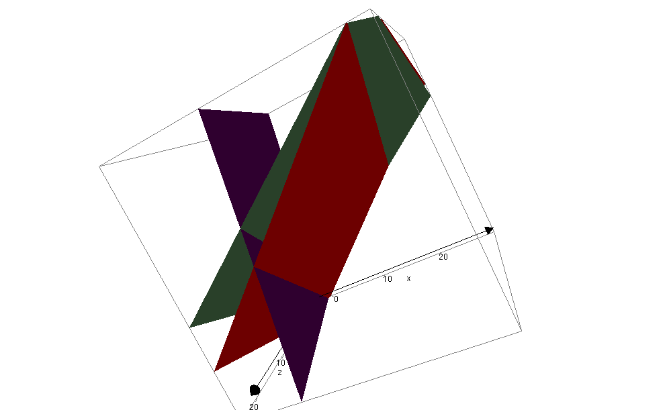
x-2y-z=6  3x+y+5z=-3  X+5y+7z=-15 |  | 