USING THE T1-82 FOR STATISTICS sheet 3

CALCULATING CORRELATION COEFFICIENT (pmcc) AND REGRESSION LINE of Y on X (least squares)

DATA IN FORM OF TWO VARIABLES  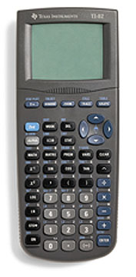 | eg:
  x | 0 | 1 | 2 | 3
  y | 4 | 7 | 8 | 11
Press STAT button, then EDIT , ENTER

Enter your x values into L₁
Enter your y values into L₂
L₁ and L₂ are the default lists for this calculator
L₁ | L₂ | L₃ | L₄ | L₅ | L₆
0 | 4
1 | 7
2 | 8
3 | 11

Press STAT button, across to CALC, down to 2 - Var Stats, ENTER
2 - Var Stats appears on the screen, press ENTER
( for other lists put in L₃ , L₄ after 2-Var Stats for example)
 | This gives:
Press STAT button, across to CALC, down to 8:LinReg(a+bx) ,ENTER
LinReg(a+bx) appears on the screen, press ENTER

This gives Lin Reg
y = a +bx
a= 4.2
b= 2.2
r² = 0.968
r = 0.9838699…
FORMULA FOR CALCULATING  PRODUCT MOMENT CORRELATION COEFICIENT |  | FORMULA FOR CALCULATING  REGRESSION LINE OF Y ON X  If y= a + bx then

