USING THE T1-82 FOR STATISTICS sheet 2

CALCULATING MEAN, MEDIAN, QUARTILES, VARIANCE
DATA IN FORM OF A FREQUENCY DISTRIBUTION  ( one variable)  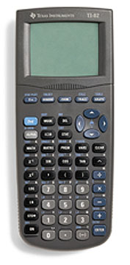 | eg:
  x | 0 | 1 | 2 | 3
  f | 4 | 12 | 33 | 26
Press STAT button, then EDIT , ENTER

Enter your x values into L₁
Enter the frequencies into L₂
L₁ | L₂ | L₃ | L₄ | L₅ | L₆
0 | 4
1 | 12
2 | 33
3 | 26

Press STAT button, across to CALC, down to 1 - Var Stats, ENTER
1 - Var Stats appears on the screen, put in L₁ , L₂ press ENTER
(note you must put a comma between L₁ and L₂ )
Check your value of n
 | This gives:
FORMULA FOR CALCULATING
THE MEAN:
FORMULA FOR CALCULATING STANDARD DEVIATION:
Note: variance = (standard deviation)²

