USING THE T1-82 FOR STATISTICS sheet 1

CALCULATING MEAN, MEDIAN, QUARTILES, VARIANCE
UNGROUPED DATA  (single variable)  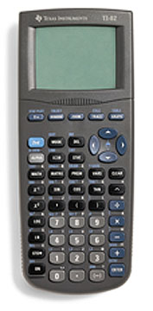 | eg: 3, 5, 6 ,1, 5, 2, 1, 2, 1, 0, 3
Press STAT button, then EDIT , ENTER

Enter your data into one of the lists
(L₁ is the default list on this calculator)
L₁ | L₂ | L₃ | L₄ | L₅ | L₆
3
5
6

Press STAT button, scroll across to CALC, 1-Var Stats, ENTER

1-Var Stats appears on the screen, either press ENTER again if you have used L_{1 ,} or put in L₂ etc (yellow button) after the 1-Var Stats

 | This gives:
FORMULA FOR CALCULATING
THE MEAN:
FORMULA FOR CALCULATING STANDARD DEVIATION:
Note: variance = (standard deviation)²

